CCNA Lab Manual
Part 1 - Configuring a Static IPv4 Network
District Shop #1 - Single-Broadcast-Domain Baseline
Student: ____________________ | Date: ____________________ | Lab Time: __________

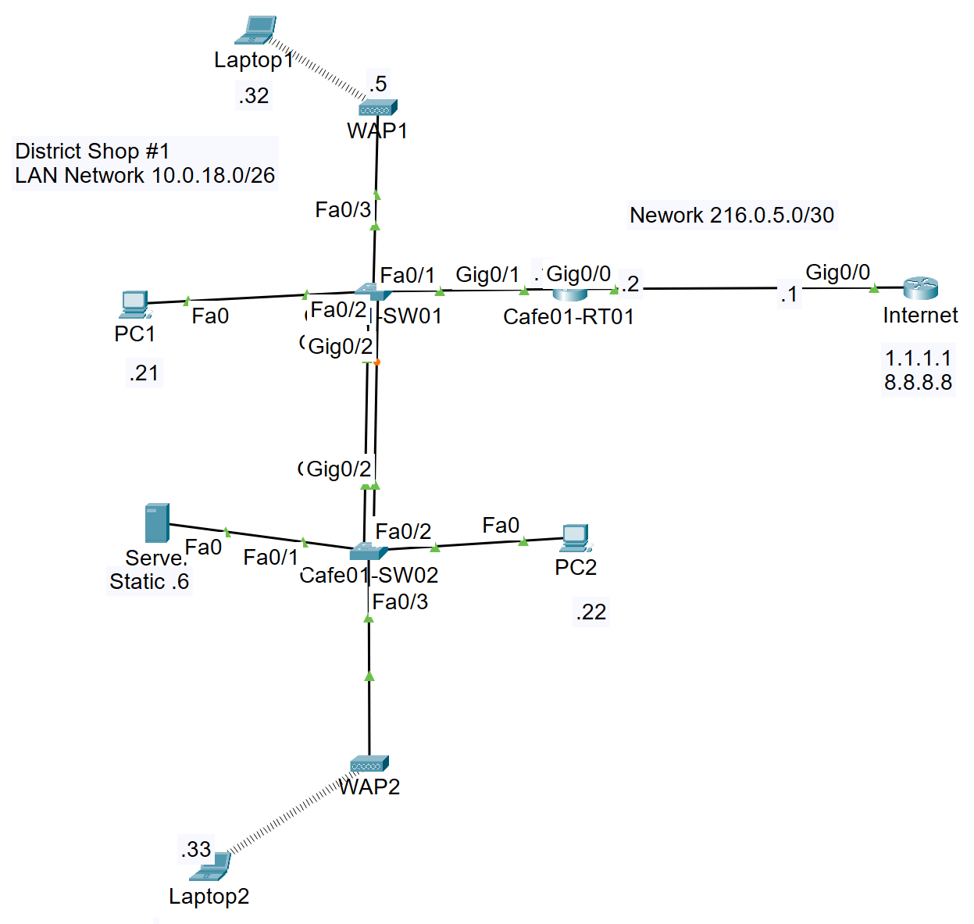
Figure 1. District Shop #1 static IPv4 topology

Lab Overview
Purpose. Build the network shown in Figure 1, configure a single IPv4 LAN with static addressing, configure routing to the simulated Internet router, and verify end-to-end connectivity to 1.1.1.1 and 8.8.8.8.
Baseline design: This lab intentionally keeps all switch ports in VLAN 1. It establishes a working static-IP baseline before later VLAN, trunking, inter-VLAN routing, and DHCP exercises.

Learning Objectives
- Cable the routers, switches, wired hosts, wireless access points, and laptops according to the topology.
- Configure static IPv4 addresses, subnet masks, and default gateways.
- Configure Layer 2 switch ports for one flat LAN.
- Configure a default route on Cafe01-RT01 and a return route on the Internet router.
- Use show, ping, and tracert/traceroute commands to verify connectivity and isolate failures.

Equipment and Assumptions
- Two Cisco 2900-series routers: Cafe01-RT01 and Internet.
- Two Cisco Catalyst 2960 switches: Cafe01-SW01 and Cafe01-SW02.
- Two PCs, one server, two wireless access points, and two wireless laptops.
- Packet Tracer interface names may vary. Use show ip interface brief and show interfaces status to confirm the actual ports.
- The simulated Internet router uses loopback addresses 1.1.1.1 and 8.8.8.8. NAT is not required because the Internet router receives a return route to the private LAN.

Addressing Plan
Device | Interface | IPv4 Address | Mask / Prefix | Default Gateway | Purpose
Cafe01-RT01 | Gi0/1 | 10.0.18.1 | 255.255.255.192 /26 | - | LAN gateway
WAP1 | Fa0 | 10.0.18.5 | 255.255.255.192 /26 | 10.0.18.1 | Wireless AP 1 management
Server | Fa0 | 10.0.18.6 | 255.255.255.192 /26 | 10.0.18.1 | Static server
WAP2 | Fa0 | 10.0.18.7 | 255.255.255.192 /26 | 10.0.18.1 | Wireless AP 2 management
PC1 | Fa0 | 10.0.18.21 | 255.255.255.192 /26 | 10.0.18.1 | Wired client
PC2 | Fa0 | 10.0.18.22 | 255.255.255.192 /26 | 10.0.18.1 | Wired client
Laptop1 | Wireless0 | 10.0.18.32 | 255.255.255.192 /26 | 10.0.18.1 | Wireless client
Laptop2 | Wireless0 | 10.0.18.33 | 255.255.255.192 /26 | 10.0.18.1 | Wireless client
Cafe01-RT01 | Gi0/0 | 216.0.5.2 | 255.255.255.252 /30 | - | WAN link
Internet | Gi0/0 | 216.0.5.1 | 255.255.255.252 /30 | - | WAN peer
Internet | Loopback0 | 1.1.1.1 | 255.255.255.255 /32 | - | Simulated Internet host
Internet | Loopback1 | 8.8.8.8 | 255.255.255.255 /32 | - | Simulated Internet host
Subnet check: The LAN is 10.0.18.0/26. Usable host addresses are 10.0.18.1-10.0.18.62, and 10.0.18.63 is the broadcast address.

Physical Port Map
Local Device | Local Port | Remote Device | Remote Port
Cafe01-RT01 | Gi0/0 | Internet | Gi0/0
Cafe01-RT01 | Gi0/1 | Cafe01-SW01 | Fa0/1
Cafe01-SW01 | Fa0/2 | PC1 | Fa0
Cafe01-SW01 | Fa0/3 | WAP1 | Fa0
Cafe01-SW01 | Gi0/2 | Cafe01-SW02 | Gi0/2
Cafe01-SW02 | Fa0/1 | Server | Fa0
Cafe01-SW02 | Fa0/2 | PC2 | Fa0
Cafe01-SW02 | Fa0/3 | WAP2 | Fa0

Part 1 - Build and Inspect the Topology

Step 1: Place and Cable the Devices
1. Place the two routers, two switches, two PCs, one server, two access points, and two laptops as shown in Figure 1.
2. Connect Cafe01-RT01 Gi0/0 to Internet Gi0/0.
3. Connect Cafe01-RT01 Gi0/1 to Cafe01-SW01 Fa0/1.
4. Connect Cafe01-SW01 Gi0/2 to Cafe01-SW02 Gi0/2.
5. Connect PC1 to Cafe01-SW01 Fa0/2 and WAP1 to Cafe01-SW01 Fa0/3.
6. Connect the Server to Cafe01-SW02 Fa0/1, PC2 to Fa0/2, and WAP2 to Fa0/3.
7. Associate Laptop1 with WAP1 and Laptop2 with WAP2 after configuring the wireless settings.
Cable selection: Packet Tracer generally supports automatic MDI/MDIX. Copper straight-through cables are appropriate for unlike devices; the switch-to-switch link may use crossover or automatic selection.

Step 2: Record the Initial Interface State
On each router:
enable
show ip interface brief

On each switch:
enable
show interfaces status
show vlan brief

Before configuration, router interfaces may be administratively down. Switch ports connected to powered devices should eventually show connected/up.

Checkpoint 1
Check | Expected Result | Student Initials
All devices are placed and cabled | Matches Figure 1
Router-to-router link | Gi0/0 <-> Gi0/0
Router-to-switch link | RT01 Gi0/1 <-> SW01 Fa0/1
Inter-switch link | SW01 Gi0/2 <-> SW02 Gi0/2

Part 2 - Configure the Internet Router
Goal. Configure the WAN address, create two loopbacks that simulate Internet destinations, and add a return route to the District Shop LAN.

Step 1: Configure Interfaces and Loopbacks
Internet> enable
Internet# configure terminal
Internet(config)# hostname Internet
Internet(config)# interface GigabitEthernet0/0
Internet(config-if)# description TO_CAFE01-RT01
Internet(config-if)# ip address 216.0.5.1 255.255.255.252
Internet(config-if)# no shutdown
Internet(config-if)# exit
Internet(config)# interface Loopback0
Internet(config-if)# description SIMULATED_INTERNET_1.1.1.1
Internet(config-if)# ip address 1.1.1.1 255.255.255.255
Internet(config-if)# exit
Internet(config)# interface Loopback1
Internet(config-if)# description SIMULATED_INTERNET_8.8.8.8
Internet(config-if)# ip address 8.8.8.8 255.255.255.255
Internet(config-if)# exit

Step 2: Correct the Return Route
Important: The supplied router configuration contained host routes to 216.0.5.20 and 216.0.5.21. Those destinations are not the internal LAN. Replace them with one route to 10.0.18.0/26.

Internet(config)# no ip route 216.0.5.20 255.255.255.255 216.0.5.2
Internet(config)# no ip route 216.0.5.21 255.255.255.255 216.0.5.2
Internet(config)# ip route 10.0.18.0 255.255.255.192 216.0.5.2
Internet(config)# end
Internet# copy running-config startup-config

Step 3: Verify the Internet Router
Internet# show ip interface brief
Internet# show ip route

Expected route: S 10.0.18.0/26 [1/0] via 216.0.5.2

Part 3 - Configure Cafe01-RT01
Goal. Configure the LAN gateway, configure the WAN connection, and add a default route to the Internet router.

Step 1: Configure Gi0/0 and Gi0/1
Cafe01-RT01> enable
Cafe01-RT01# configure terminal
Cafe01-RT01(config)# hostname Cafe01-RT01
Cafe01-RT01(config)# interface GigabitEthernet0/0
Cafe01-RT01(config-if)# description WAN_TO_INTERNET
Cafe01-RT01(config-if)# ip address 216.0.5.2 255.255.255.252
Cafe01-RT01(config-if)# no shutdown
Cafe01-RT01(config-if)# exit
Cafe01-RT01(config)# interface GigabitEthernet0/1
Cafe01-RT01(config-if)# description LAN_TO_CAFE01-SW01
Cafe01-RT01(config-if)# ip address 10.0.18.1 255.255.255.192
Cafe01-RT01(config-if)# no shutdown
Cafe01-RT01(config-if)# exit

Step 2: Configure the Default Route
Cafe01-RT01(config)# ip route 0.0.0.0 0.0.0.0 216.0.5.1
Cafe01-RT01(config)# end
Cafe01-RT01# copy running-config startup-config

Routing logic: Cafe01-RT01 uses a default route for all unknown destinations. The Internet router uses a specific return route to send replies back to 10.0.18.0/26.

Step 3: Verify Cafe01-RT01
Cafe01-RT01# show ip interface brief
Cafe01-RT01# show ip route
Cafe01-RT01# ping 216.0.5.1
Cafe01-RT01# ping 8.8.8.8

Expected: Gi0/0 and Gi0/1 are up/up, the default route points to 216.0.5.1, and both pings succeed.

Part 4 - Configure the Layer 2 Switches
Layer 2 note: The switches do not require IP addresses to forward Ethernet frames. All connected ports remain in VLAN 1 for this baseline lab.

Step 1: Configure Cafe01-SW01
Switch> enable
Switch# configure terminal
Switch(config)# hostname Cafe01-SW01
Cafe01-SW01(config)# interface FastEthernet0/1
Cafe01-SW01(config-if)# description TO_CAFE01-RT01_G0/1
Cafe01-SW01(config-if)# switchport mode access
Cafe01-SW01(config-if)# switchport access vlan 1
Cafe01-SW01(config-if)# no shutdown
Cafe01-SW01(config-if)# exit
Cafe01-SW01(config)# interface FastEthernet0/2
Cafe01-SW01(config-if)# description TO_PC1
Cafe01-SW01(config-if)# switchport mode access
Cafe01-SW01(config-if)# switchport access vlan 1
Cafe01-SW01(config-if)# no shutdown
Cafe01-SW01(config-if)# exit
Cafe01-SW01(config)# interface FastEthernet0/3
Cafe01-SW01(config-if)# description TO_WAP1
Cafe01-SW01(config-if)# switchport mode access
Cafe01-SW01(config-if)# switchport access vlan 1
Cafe01-SW01(config-if)# no shutdown
Cafe01-SW01(config-if)# exit
Cafe01-SW01(config)# interface GigabitEthernet0/2
Cafe01-SW01(config-if)# description TO_CAFE01-SW02_G0/2
Cafe01-SW01(config-if)# switchport mode access
Cafe01-SW01(config-if)# switchport access vlan 1
Cafe01-SW01(config-if)# no shutdown
Cafe01-SW01(config-if)# end
Cafe01-SW01# copy running-config startup-config

Step 2: Configure Cafe01-SW02
Switch> enable
Switch# configure terminal
Switch(config)# hostname Cafe01-SW02
Cafe01-SW02(config)# interface FastEthernet0/1
Cafe01-SW02(config-if)# description TO_SERVER
Cafe01-SW02(config-if)# switchport mode access
Cafe01-SW02(config-if)# switchport access vlan 1
Cafe01-SW02(config-if)# no shutdown
Cafe01-SW02(config-if)# exit
Cafe01-SW02(config)# interface FastEthernet0/2
Cafe01-SW02(config-if)# description TO_PC2
Cafe01-SW02(config-if)# switchport mode access
Cafe01-SW02(config-if)# switchport access vlan 1
Cafe01-SW02(config-if)# no shutdown
Cafe01-SW02(config-if)# exit
Cafe01-SW02(config)# interface FastEthernet0/3
Cafe01-SW02(config-if)# description TO_WAP2
Cafe01-SW02(config-if)# switchport mode access
Cafe01-SW02(config-if)# switchport access vlan 1
Cafe01-SW02(config-if)# no shutdown
Cafe01-SW02(config-if)# exit
Cafe01-SW02(config)# interface GigabitEthernet0/2
Cafe01-SW02(config-if)# description TO_CAFE01-SW01_G0/2
Cafe01-SW02(config-if)# switchport mode access
Cafe01-SW02(config-if)# switchport access vlan 1
Cafe01-SW02(config-if)# no shutdown
Cafe01-SW02(config-if)# end
Cafe01-SW02# copy running-config startup-config

Step 3: Verify the Switches
Cafe01-SW01# show interfaces status
Cafe01-SW01# show vlan brief
Cafe01-SW02# show interfaces status
Cafe01-SW02# show vlan brief

Expected: The connected ports show connected, and Fa0/1-Fa0/3 plus Gi0/2 appear in VLAN 1.

Part 5 - Configure Static IP Addresses

Step 1: Configure PC1, PC2, and the Server
1. Open the device.
2. Select Desktop > IP Configuration.
3. Select Static.
4. Enter the IPv4 address, subnet mask, default gateway, and optional DNS address shown in the table below.
Device | IP Address | Subnet Mask | Gateway | DNS (optional)
Server | 10.0.18.6 | 255.255.255.192 | 10.0.18.1 | 8.8.8.8
PC1 | 10.0.18.21 | 255.255.255.192 | 10.0.18.1 | 8.8.8.8
PC2 | 10.0.18.22 | 255.255.255.192 | 10.0.18.1 | 8.8.8.8

Step 2: Configure WAP1 and WAP2
1. Open WAP1 and select Config.
2. Assign WAP1 the address 10.0.18.5, mask 255.255.255.192, and gateway 10.0.18.1.
3. Configure an SSID such as DISTRICT-SHOP-WAP1. Use instructor-provided wireless security settings.
4. Open WAP2 and assign 10.0.18.7, mask 255.255.255.192, and gateway 10.0.18.1.
5. Configure an SSID such as DISTRICT-SHOP-WAP2 using the same approved security method.
Packet Tracer variation: The exact access-point tabs vary by device model. Configure the wired management interface and the wireless SSID. The AP must not run a conflicting DHCP service in this static-address lab.

Step 3: Configure Laptop1 and Laptop2
1. Associate Laptop1 with DISTRICT-SHOP-WAP1.
2. Assign Laptop1 10.0.18.32/26 with gateway 10.0.18.1.
3. Associate Laptop2 with DISTRICT-SHOP-WAP2.
4. Assign Laptop2 10.0.18.33/26 with gateway 10.0.18.1.
Device | IP Address | Subnet Mask | Gateway | SSID
Laptop1 | 10.0.18.32 | 255.255.255.192 | 10.0.18.1 | DISTRICT-SHOP-WAP1
Laptop2 | 10.0.18.33 | 255.255.255.192 | 10.0.18.1 | DISTRICT-SHOP-WAP2

Part 6 - Verify Connectivity

Step 1: Verify Local LAN Connectivity
From PC1, open Desktop > Command Prompt and run:
ipconfig
ping 10.0.18.1
ping 10.0.18.6
ping 10.0.18.22
ping 10.0.18.32
ping 10.0.18.33

First-ping behavior: The first echo may time out while ARP resolves a MAC address. Repeat the ping before concluding that the path is broken.

Step 2: Verify the WAN and Simulated Internet
ping 216.0.5.2
ping 216.0.5.1
ping 1.1.1.1
ping 8.8.8.8
tracert 8.8.8.8

Test | What It Verifies | Expected
Ping 10.0.18.1 | Access port, local switching, and LAN gateway | Success
Ping another 10.0.18.x host | Layer 2 forwarding across one or both switches | Success
Ping 216.0.5.2 | Cafe01-RT01 routes from LAN to its WAN interface | Success
Ping 216.0.5.1 | WAN link and Internet-router return route | Success
Ping 8.8.8.8 | Complete end-to-end simulated Internet routing | Success

Step 3: Verify Routing from Both Routers
Cafe01-RT01:
show ip interface brief
show ip route
ping 216.0.5.1
ping 8.8.8.8

Internet router:
show ip interface brief
show ip route
ping 216.0.5.2
ping 10.0.18.1

Key lesson: A working forward path is not enough. The Internet router needs the route 10.0.18.0/26 via 216.0.5.2 so replies can return to the private LAN.

Part 7 - Troubleshooting Guide
Symptom | Likely Cause | Corrective Action
PC cannot ping 10.0.18.1 | Wrong IP/mask/gateway, access port down, or router Gi0/1 down | Verify static settings, cabling, switch status, and no shutdown.
PC can ping 216.0.5.2 but not 216.0.5.1 | Internet router lacks return route to 10.0.18.0/26 | Configure ip route 10.0.18.0 255.255.255.192 216.0.5.2.
Router can ping 8.8.8.8 but PC cannot | PC gateway is missing or return route is incorrect | Verify 10.0.18.1 on the PC and the Internet-router route.
Hosts on different switches cannot ping | Gi0/2 link is down or ports are in different VLANs | Verify both Gi0/2 ports are connected/up and in VLAN 1.
Laptop cannot reach the LAN | SSID/security mismatch or wrong static IP | Reconnect to the correct SSID and verify /26 mask and gateway.
Intermittent or incorrect replies | Duplicate static IP address | Check the addressing table and assign every device a unique address.
169.254.x.x address appears | The device is using DHCP and failed to obtain a lease | Select Static and enter the assigned address manually.

Useful Diagnostic Commands
! Router
show ip interface brief
show ip route
show running-config
ping <destination>
traceroute <destination>
! Switch
show interfaces status
show vlan brief
show mac address-table
show cdp neighbors
! PC / Laptop
ipconfig
ping <destination>
tracert <destination>

Lab Completion Checklist
Completion Item | Complete
Cafe01-RT01 Gi0/1 is 10.0.18.1/26 and is up/up. | [ ]
Cafe01-RT01 Gi0/0 is 216.0.5.2/30 and is up/up. | [ ]
Internet Gi0/0 is 216.0.5.1/30 and is up/up. | [ ]
Internet has Loopback0 1.1.1.1/32 and Loopback1 8.8.8.8/32. | [ ]
Cafe01-RT01 has a default route via 216.0.5.1. | [ ]
Internet has a return route to 10.0.18.0/26 via 216.0.5.2. | [ ]
All wired and wireless devices have the assigned static IPv4 settings. | [ ]
PC1 can ping PC2, Server, Laptop1, and Laptop2. | [ ]
PC1 and PC2 can ping 8.8.8.8. | [ ]
Router and switch configurations are saved. | [ ]

Knowledge Check
1. What is the usable host range for 10.0.18.0/26?
________________________________________________________________________________
________________________________________________________________________________
2. Why is 10.0.18.63 not a valid host address?
________________________________________________________________________________
________________________________________________________________________________
3. Why does Cafe01-RT01 need a default route?
________________________________________________________________________________
________________________________________________________________________________
4. Why does the Internet router need a return route to 10.0.18.0/26?
________________________________________________________________________________
________________________________________________________________________________
5. Why can the two switches forward LAN traffic without having management IP addresses?
________________________________________________________________________________
________________________________________________________________________________
6. What does a successful ping to 216.0.5.2 prove? What additional function is tested by pinging 216.0.5.1?
________________________________________________________________________________
________________________________________________________________________________

Student Reflection
Describe one configuration error you encountered and the command or test that helped you identify it.
________________________________________________________________________________
________________________________________________________________________________
________________________________________________________________________________
________________________________________________________________________________
________________________________________________________________________________
________________________________________________________________________________
________________________________________________________________________________
________________________________________________________________________________
________________________________________________________________________________
________________________________________________________________________________
________________________________________________________________________________
________________________________________________________________________________
________________________________________________________________________________
________________________________________________________________________________

